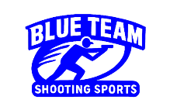Stage 1 – I’m puttin together a special team
COURSE DESIGNER: Ike Starnes
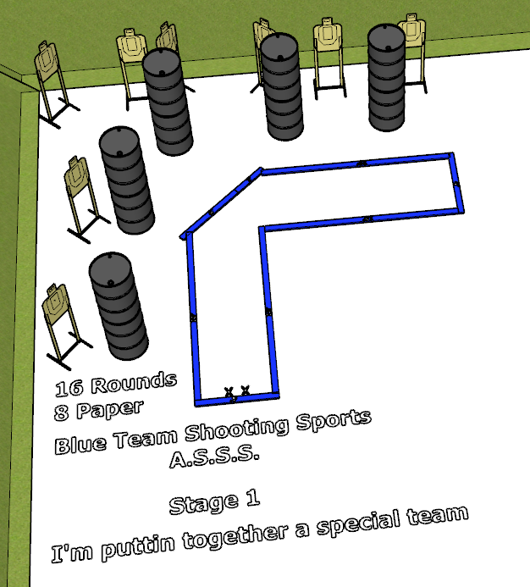

Written Stage Briefing:
Stage 1 – I’m putting together a special team is a 16 round, 80 point, Comstock course. There are 8 cardboard targets. The best 2 hits per cardboard target will be scored.
Start position Both feet on the Shooting Sports Innovations Xs.
Handgun: Loaded and holstered, wrists below belt
PCC: Loaded, stock touching belt
On the audible start signal, engage targets from within the shooting area.

